22nd August 2017

**YOKOHAMA Denmark continues strong links to Motorsport**

Members of YOKOHAMA Denmark hosted a group of over 400 invited dealers who visited their hospitality during the annual Danish Grand Prix at "Jyllands-Ringen". At the weekend, 5 classes used Yokohama tyres (DTC, Yokohama 2000 Supercup, YOKOHAMA 1600 Challenge, Super Seven and the Legends Cup.)

Although the weather was unstable throughout with wet and dry intermittent periods this did not dampen the spirits of guests or competitors and YOKOHAMA’s racing agent Gunnar Aaskov was kept busy servicing the various teams and drivers.

During the same weekend, the 3rd round of the YOKOHAMA Rallysprint Championship also took place near Copenhagen with the participation of approximately 50 cars.

Pressed to comment, YOKOHAMA Denmark’s General Manager Kenneth Saust, expressed his delight with the weekend’s activities and the strong performances of the competitors. “It has been a very active weekend indeed for all of us and our service team but we are very glad with the way things have gone”. “As YOKOHAMA celebrates 100 years in October, we are also encouraged by all the positive comments received from the racing teams and we are looking forward to continuing our strong relationship to Motorsports.” He concluded.

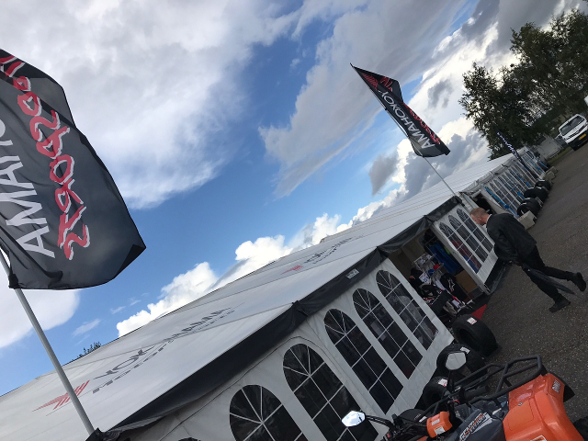

*Yokohama Denmark Hospitality Tent at Grand Prix*

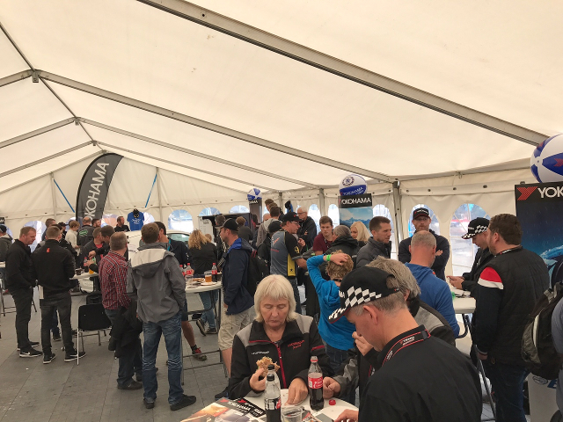

*Yokohama Denmark hosts invited dealers to Grand Prix*

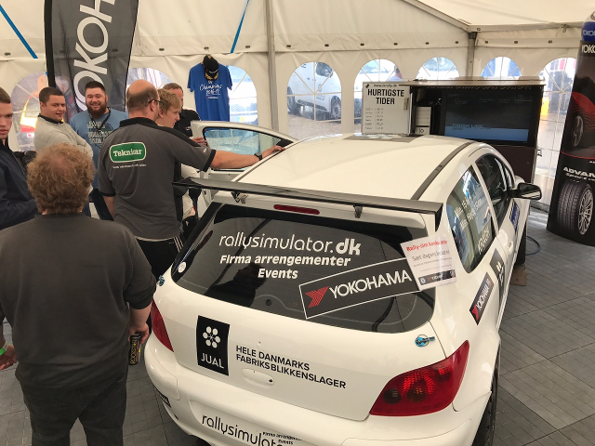

*Activities and Specialist advice was available during the weekend*